# https://upload.wikimedia.org/wikipedia/en/f/f1/Capital_University%2C_Jharkhand_logo.png

# CAPITAL UNIVERSITY - KODERMA

CONTROL ENGINEERGING ASSIGNMENT

Name : Arshad Nazir

Electrical and Electronics Engineering

Signature:

Date :

# PART I

**UNIVERSITY EXAM QUESTION PATTERN – 6 MARK (EACH QUESTION CARRIES 2 MARKS)**

# What is control system?

**Ans:**A control system is defined as a system of devices that manages, commands, directs, or regulates the behaviour of other devices or systems to achieve a desired result. A control system achieves this through control loops, which are a process designed to maintain a process variable at a desired set point.

# Define open loop control system.

**Ans:**An open-loop system is a type of control system in which the output of the system depends on the input but the input or the controller is independent of the output of the system. These systems do not contain any feedback loop and thus are also known as non-feedback system.

The figure here represents the block diagram of an open-loop control system:

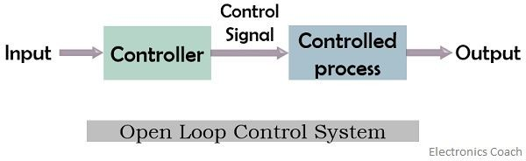

# Define closed loop control system.

**Ans:**A **Closed-loop Control System**, also known as a *feedback control system* is a control system which uses the concept of an open loop system as its forward path but has one or more feedback loops (hence its name) or paths between its output and its input. The reference to “feedback”, simply means that some portion of the output is returned “back” to the input to form part of the systems excitation.

**Closed-loop Control**

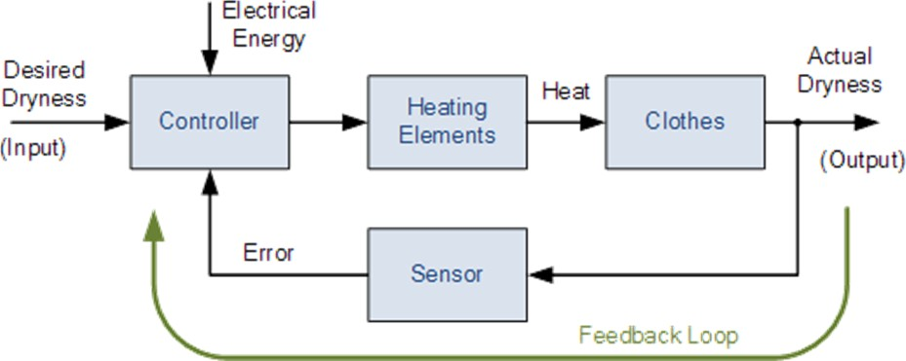

1. **Define transfer function.**

**Ans:**The transfer function of a system is defined as the ratio of Laplace transform output to Laplace transform of input with zero initial conditions.

# What are the basic elements used for modelling mechanical rotational system? Ans:

* + Moment of inertia J,
  + dashpot with rotational frictional coefficient B and
  + Rotations spring with stiffness K

# Name two types of electrical analogous for mechanical system. Ans:.

* + Force Voltage Analogy
  + Torque Voltage Analogy

# What is block diagram?

**Ans:**A block diagram of a system is a pictorial representation of the functions performed by each component of the system and shows the flow of signals. The basic elements

of block diagram are block, branch point and summing point

# What is the basis for framing the rules of block diagram reduction technique?

**Ans:** The rules for block diagram reduction technique are framed such that any modification made on the diagram does not alter the input output relation

# What is a signal flow graph?

**Ans:** A signal flow graph is a diagram that represents a set of simultaneous algebraic equations. By taking

L.T the time domain differential equations governing a control system can be transferred to a set of algebraic equations in s-domain

# What is transmittance?

**Ans:** The transmittance is the gain acquired by the signal when it travels from one node to another node in signal flow graph.

# What is sink and source?

**Ans:** Source is the input node in the signal flow graph and it has only outgoing branches. Sink is an output node in the signal flow graph and it has only incoming branches.

# Define non- touching loop.

**Ans:** Non-touching loop: Loop is said to be non-touching if they do not have any common node. Forward path gain: A product of all branches gain along the forward path is called Forward path gain.

# Write Masons Gain formula. Ans: Mason’s gain formula is

T=C(s)R(s)=ΣNi=1PiΔiΔT=C(s)R(s)=Σi=1NPiΔiΔ

Where,

* + **C(s)** is the output node
  + **R(s)** is the input node
  + **T** is the transfer function or gain between R(s)R(s) and C(s)C(s)
  + **Pi** is the ith forward path gain

Δ=1−(sumofallindividualloopgains)Δ=1−(sumofallindividualloopgains)

+(sumofgainproductsofallpossibletwonontouchingloops)+(sumofgainproductsofallpossibletwonontouchingloo ps)

−(sum of gain products of all possible three non-touching loops)+...

# Write the force balance equation of m ideal mass element. Ans:

F = M d2x/dt2

# Write the force balance equation of ideal dashpot element Ans:

F = B dx/dt

# PART IA

**UNIVERSITY EXAM QUESTION PATTERN – 6 MARK (EACH QUESTION CARRIES 6 MARKS)**

# Derive the transfer function for Armature controlled DC servo motor.

**Ans:** The speed of a dc motor can be controlled by varying the voltage applied to the armature of a dc motor. A separately excited dc motor with variable armature voltage finds application as a drive motor in a variable speed drive. The variable armature voltage is provided by a phase controlled rectifier. The schematic of an Transfer Function of Armature Controlled DC Motor is shown in Fig. 6.7.

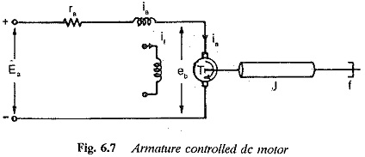

The torque developed by the dc motor



where

**Φ is air gap flux**

**ia is armature current K is a constant**

Neglecting the affects of saturation and armature reaction we have the air gap flux proportional to the field current. That is

Because if is constant the torque developed is given by



where Kt is motor constant. The armature voltage ea is supplied by the thyristor converter. The armature circuit

equation is given by

eb in Eq. 6.7 is the rotational (back) emf induced in the armature and is proportional to the product of speed and flux. But, the flux of the motor is constant. Therefore, The dynamic equation of the motor giving the torque

balance can be written as 

Assuming the initial conditions to be zero, Laplace transforms of Eqs 6.7, 6.8 and 6.9 can be written as

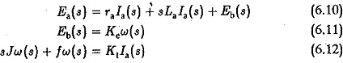

Taking Ea(s) as the input and w(s) as the output, the transfer function w(s)/Ea(s) can be obtained by eliminating la(s) from the equations and is given by



The block diagram given in Fig. 6.8(a) represents Eq. 6.13. This can be finally reduced to a single block given in Fig. 6.8(b).

Normally the armature inductance La is very small and may be neglected. The transfer function in this case is given by

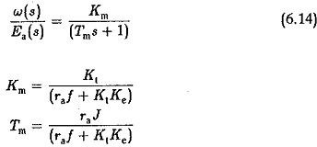

It can be seen that the back emf affects the damping of the system. A transfer function between the speed and load torque can be derived by assuming the other input ea to be zero. In this case the dynamic equation would be

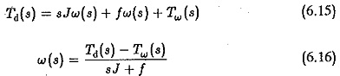

But from Eqs 6.10 and 6.11 we have



Substituting in Eq. 6.15 and simplifying we get

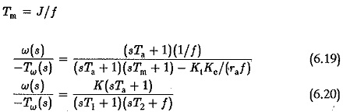

where K is constant. If the poles of this transfer function are complex conjugates the speed change for a change in the load torque is oscillatory.

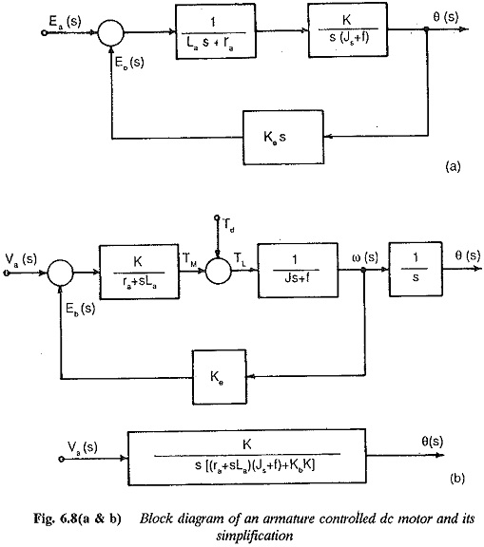

# Derive the transfer function for Field controlled DC servo motor.

**Ans:** The speed of a dc motor can be varied by varying the field current. The speed can be increased beyond base speed by decreasing the field current. The Fig. 6.8(c&d) shows the Transfer Function of a Field Controlled DC Motor. In this type of control constant torque operation is not possible as the armature current would increase to dangerous values at low fluxes. It is therefore necessary to maintain the armature current at a constant value at all flux levels. The field current is varied. The armature is also supplied by means of a phase controlled rectifier to maintain constant armature current. While deriving the transfer function the effects of saturation and armature reaction are neglected.

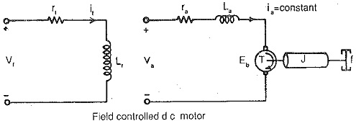

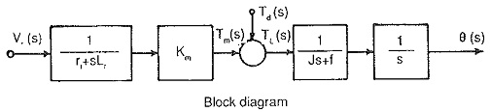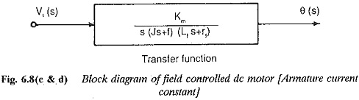

# PART II

**UNIVERSITY EXAM QUESTION PATTERN – 6 MARK (EACH QUESTION CARRIES 2 MARKS)**

# What is Proportional controller and what are its advantages?

**Ans:** it is the simplest controller among the PID family. As the name suggests, the output (actuating signal) for the control action is directly proportional to the error signal. It repeats a measurement-computation- action procedure at every loop sample time ‘T’ like all automatic controllers.

# What is the drawback in P-controller? Ans:

A **drawback** of **proportional control** is that it cannot eliminate the residual SP − PV error in processes with

compensation e.g. temperature **control**, as it requires an error to generate a **proportional** output.

# What is integral control action?

**Ans:**Integral action enables PI controllers to eliminate offset, a major weakness of a P-only controller. Thus, PI controllers provide a balance of complexity and capability that makes them by far the most widely used algorithm in process control applications.

# What is the advantage and disadvantage in integral controller? Ans:Advantages:

1. The proportional controller helps in reducing the steady-state error, thus makes the system more stable.
2. The slow response of the overdamped system can be made faster with the help of these controllers.

Disadvantages

1. Due to the presence of these controllers, we get some offsets in the system.
2. Proportional controllers also increase the maximum overshoot of the system.

# What is PI controller? Ans:

The proportional integral controller produces an output, which is the combination of outputs of the proportional and integral controllers.

# What is PD controller? Ans:

The proportional derivative controller produces an output, which is the combination of the outputs of proportional and derivative controllers.

# What is PID controller? Ans:

The proportional integral derivative controller produces an output, which is the combination of the outputs of proportional, integral and derivative controllers.

# What is time response? Ans:

If the output of control system for an input varies with respect to time, then it is called the time response of the control system. The time response consists of two parts.

Transient response Steady state response

# Define Ramp signal:

**Ans:**

The ramp signal is a signal whose value increases linearly with time from an initial value of zero at t=0. The ramp signal resembles a constant velocity

# PART IIA

**UNIVERSITY EXAM QUESTION PATTERN – 6 MARK (EACH QUESTION CARRIES 6 MARKS)**

# (a) Derive the expressions and draw the response of first order system for unit step input. Ans:

Response of 1st order system when the input is unit step -

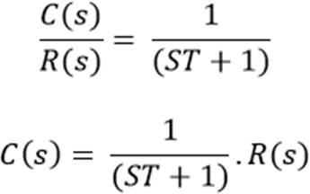

For Unit Step,

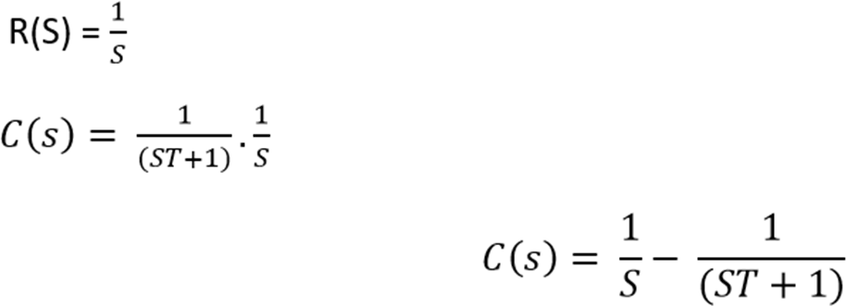

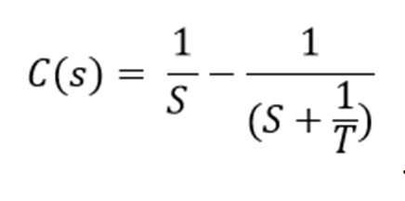Now, the partial fraction of above equation will be:

Taking the inverse Laplace of above equation is:

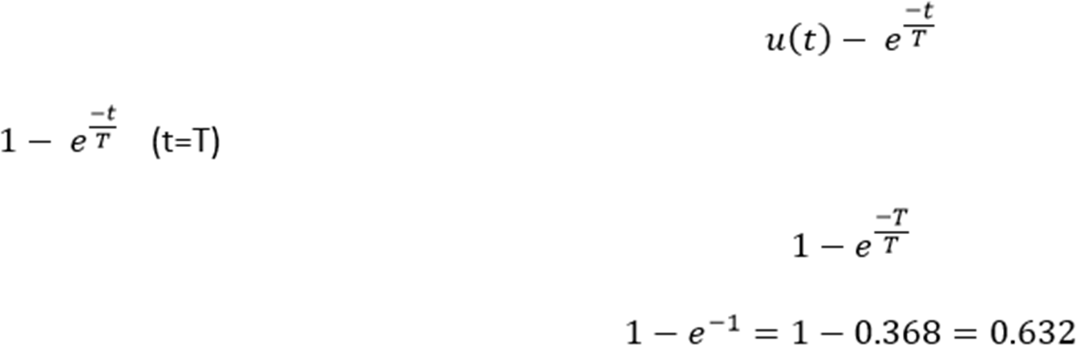

Where T is known as time constant of the system and it is defined as the time required for the signal to attain

63.2 % of final or steady state value. Time constant means how fast the system reaches the final value. As smaller the time constant, as faster is the system response. If time constant is larger, system goes to move slow.

# (b) Draw the response of second order system for critically damped case and when input is unit step. Ans:

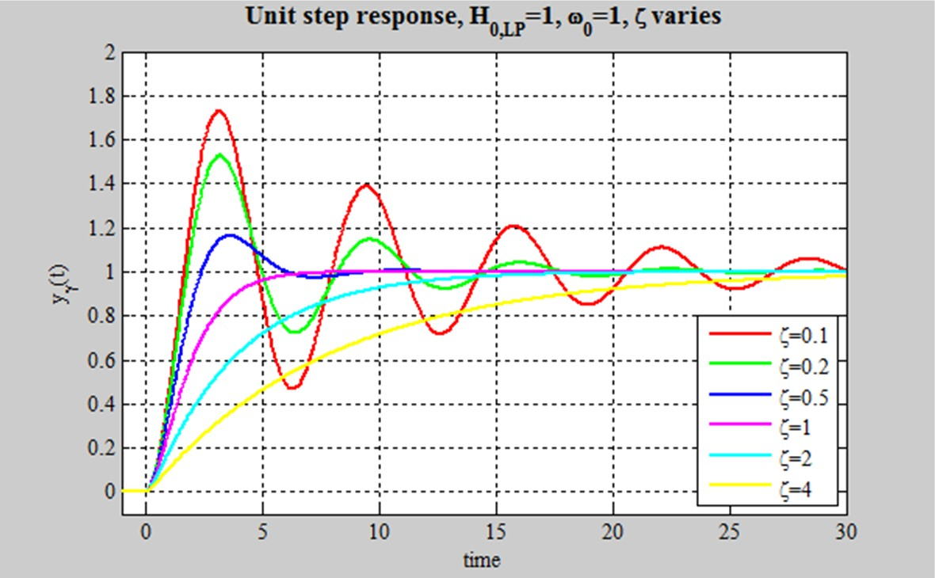

* 1. **Derive the expressions for Rise time, Peak time, and Peak overshoot. Ans:**

It is the time required for the response to rise from **0% to 100% of its final value**. This is applicable for the **under-damped systems**. For the over-damped systems, consider the duration from 10% to 90% of the final value. Rise time is denoted by **tr**.

At t = t1 = 0, c(t) = 0.

We know that the final value of the step response is one.

Therefore, at t=t2t=t2, the value of step response is one. Substitute, these values in the following equation. c(t)=1−(e−δωnt1−δ2−−−−−√)sin(ωdt+θ)c(t)=1−(e−δωnt1−δ2)sin (ωdt+θ)

c(t2)=1=1−(e−δωnt21−δ2−−−−−√)sin(ωdt2+θ)c(t2)=1=1−(e−δωnt21−δ2)sin (ωdt2+θ)

⇒(e−δωnt21−δ2−−−−−√)sin(ωdt2+θ)=0 ⇒(e−δωnt21−δ2)sin (ωdt2+θ)=0

⇒sin(ωdt2+θ)=0⇒sin (ωdt2+θ)=0

⇒ωdt2+θ=π⇒ωdt2+θ=π

⇒t2=π−θωd⇒t2=π−θωd

Substitute t1 and t2 values in the following equation of **rise time**,

tr=t2−t1tr=t2−t1

∴tr=π−θωd∴tr=π−θωd

From above equation, we can conclude that the rise time trtr and the damped frequency ωdωd are inversely proportional to each other.

# Peak Time

It is the time required for the response to reach the **peak value** for the first time. It is denoted by tptp. At t=tpt=tp, the first derivate of the response is zero.

We know the step response of second order system for under-damped case is c(t)=1−(e−δωnt1−δ2−−−−−√)sin(ωdt+θ)c(t)=1−(e−δωnt1−δ2)sin (ωdt+θ)

Differentiate c(t)c(t) with respect to ‘t’. dc(t)dt=−(e−δωnt1−δ2−−−−−√)ωdcos(ωdt+θ)−(−δωne−δωnt1−δ2−−−−−√)sin(ωdt+θ)dc(t)dt=−(e−δωnt1−δ2)ωdc

os (ωdt+θ)−(−δωne−δωnt1−δ2)sin (ωdt+θ)

Substitute, t=tpt=tp and dc(t)dt=0dc(t)dt=0 in the above equation. 0=−(e−δωntp1−δ2−−−−−√)[ωdcos(ωdtp+θ)−δωnsin(ωdtp+θ)]0=−(e−δωntp1−δ2)[ωdcos (ωdtp+θ)−δωnsin (ω

dtp+θ)]

⇒ωn1−δ2−−−−−√cos(ωdtp+θ)−δωnsin(ωdtp+θ)=0⇒ωn1−δ2cos (ωdtp+θ)−δωnsin (ωdtp+θ)=0

⇒1−δ2−−−−−√cos(ωdtp+θ)−δsin(ωdtp+θ)=0⇒1−δ2cos (ωdtp+θ)−δsin (ωdtp+θ)=0

⇒sin(θ)cos(ωdtp+θ)−cos(θ)sin(ωdtp+θ)=0⇒sin (θ)cos (ωdtp+θ)−cos (θ)sin (ωdtp+θ)=0

⇒sin(θ−ωdtp−θ)=0⇒sin (θ−ωdtp−θ)=0

⇒sin(−ωdtp)=0⇒−sin(ωdtp)=0⇒sin(ωdtp)=0⇒sin(−ωdtp)=0⇒−sin (ωdtp)=0⇒sin(ωdtp)=0

⇒ωdtp=π⇒ωdtp=π

⇒tp=πωd⇒tp=πωd

From the above equation, we can conclude that the peak time tptp and the damped frequency ωdωd are inversely proportional to each other.

# Peak Overshoot

Peak overshoot **Mp** is defined as the deviation of the response at peak time from the final value of response. It is also called the **maximum overshoot**.

Mathematically, we can write it as

Mp=c(tp)−c(∞)Mp=c(tp)−c(∞)

Where,

c(tp) is the peak value of the response.

c(∞) is the final (steady state) value of the response.

At t=tpt=tp, the response c(t) is -

c(tp)=1−(e−δωntp1−δ2−−−−−√)sin(ωdtp+θ)c(tp)=1−(e−δωntp1−δ2)sin (ωdtp+θ)

Substitute, tp=πωdtp=πωd in the right hand side of the above equation. c(tP)=1−⎛𝗁e−δωn(πωd)1−δ2−−−−−√⎞⎠sin(ωd(πωd)+θ)c(tP)=1−(e−δωn(πωd)1−δ2)sin (ωd(πωd)+θ)

⇒c(tp)=1−⎛𝗁⎜⎜⎜e−(δπ1−δ2√)1−δ2−−−−−√⎞⎠⎟⎟⎟(−sin(θ))⇒c(tp)=1−(e−(δπ1−δ2)1−δ2)(−sin (θ))

We know that

So, we will get c(tp)c(tp) as

sin(θ)=1−δ2−−−−−√sin (θ)=1−δ2

c(tp)=1+e−(δπ1−δ2√)c(tp)=1+e−(δπ1−δ2)

Substitute the values of c(tp)c(tp) and c(∞)c(∞) in the peak overshoot equation.

Mp=1+e−(δπ1−δ2√)−1Mp=1+e−(δπ1−δ2)−1

⇒Mp=e−(δπ1−δ2√)⇒Mp=e−(δπ1−δ2)

**Percentage of peak overshoot %** MpMp can be calculated by using this formula.

%Mp=Mpc(∞)×100%%Mp=Mpc(∞)×100%

By substituting the values of MpMp and c(∞)c(∞) in above formula, we will get the Percentage of the peak overshoot %Mp%Mp as

%Mp=⎛𝗁⎜e−(δπ1−δ2√)⎞⎠⎟×100%%Mp=(e−(δπ1−δ2))×100%

From the above equation, we can conclude that the percentage of peak overshoot %Mp%Mp will decrease if the damping ratio δ increases.

# PART III

**UNIVERSITY EXAM QUESTION PATTERN – 6 MARK (EACH QUESTION CARRIES 2 MARKS)**

# What is frequency response?

**Ans:**The response of a system can be partitioned into both the transient response and the steady state response. We can find the transient response by using Fourier integrals. The steady state response of a system for an input sinusoidal signal is known as the **frequency response**

# What are advantages of frequency response analysis? Ans:

1. Transfer functions which are complicated to determine the behavior of the experimentally can be determined using the frequency response analysis.
2. Design of the system and adjusting the parameters of the system can be easily carried out.
3. Corrective measurement for noise disturbance generated in the system and parameters variation can be easily determined using frequency analysis.
4. Absolute and Relative stability of the closed-loop system can be estimated from the knowledge of the open loop frequency system.
5. Frequency domain analysis can also be carried out for the nonlinear control systems.

# What are frequency domain specifications?

**Ans:** Resonant peak, resonant frequency and bandwidth are the frequency domain specifications

# Define Resonant Peak.

**Ans:** It is the peak (maximum) value of the magnitude of T(jω)T(jω). It is denoted by MrMr.

# What is resonant frequency?

**Ans:** It is the frequency at which the magnitude of the frequency response has peak value for the first time. It is denoted by ωrωr. At ω=ωrω=ωr, the first derivate of the magnitude of T(jω)T(jω) is zero.

# Define Bandwidth. Ans:

It is the range of frequencies over which, the magnitude of T(jω)T(jω) drops to 70.7% from its zero frequency value.

# What is cut-off rate?

**Ans:** The cutoff rate is the slope of the log-magnitude curve near the cutoff frequency. The cutoff rate indicates the ability of a system to distinguish the signal from noise. It is noted that a closed-loop frequency response curve with a steep cutoff characteristic may have a large resonant peak magnitude, which implies that the system has relatively small stability margin.

# Define gain margin.

**Ans:** The gain margin, Kg is defined as the value of gain to be added to system, in order to bring the system,to the verge of instability

The gain margin is the gain perturbation that makes the system marginally stable.

# Define phase margin.

**Ans:**Phase margin is the amount of phase shift when the (VFB) amplifier's gain passes through 0dB. It is basically a measure of how close the second pole of the system is to causing instability.

# 11. What is Bode plot? Ans:

In electrical engineering and control theory, a Bode plot /ˈboʊdi/ is a graph of the frequency response of a system. It is usually a combination of a Bode magnitude plot, expressing the magnitude (usually in decibels) of the frequency response, and a Bode phase plot, expressing the phase shift.

# PART IIIA

**UNIVERSITY EXAM QUESTION PATTERN – 6 MARK (EACH QUESTION CARRIES 6 MARKS)**

# 1. Plot the Bode diagram for the following transfer function and obtain the gain and phase cross over frequencies: G(S) = 10/ S(1+0.4S) (1+0.1S)

**Ans:**

The sinusoidal transfer function G(jω) is obtained by replacing s by jω in the given transfer function.

G (jω) = 10

jω(1+0.4jω)(1+0.1jω)

# MAGNITUDE PLOT:

The corner frequencies are,

ωc1 = 1/0.4 = 2.5 r/s

ωc2 = 1/0.1 = 10 r/s

The various terms of G(jω) are listed in Tatile-1 in the increasing order of their corner frequency. Also the table shows the slope contributed by each term and the change in slope at the comer frequency.

# TABLE-1

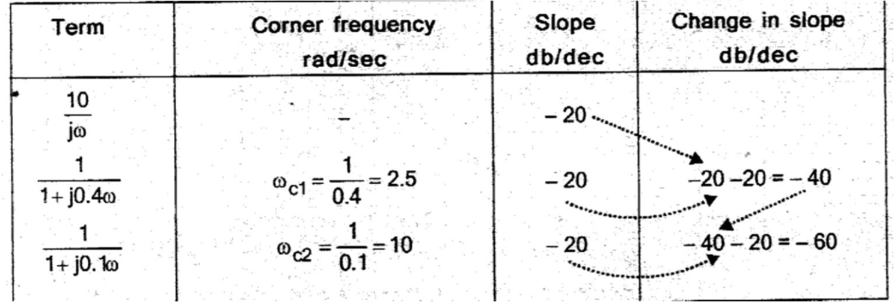

Chose a low frequency ωl such that ωl< ωc1 and chose a high frequency ωh such that ωh> ωc2. Let ωl=0.1 r/s and ωh=50 r/s.

Let A= |(jω)| in db.

Let us calculate A at ωl, ωc1, ωc2 and ωh. At ω= ωl, A= 20log|

10

jω

| = 20log(10/0.1) = 40db. At ω= ωc1, A= 20log|

10

jω| = 20log(10/2.5 = 12db.

At ω= ωc2, A= [slope from ωc1 to ωc2×log ωc2

ωc1

] + A(at ω= ωc1)

= -40×log(10/2.5)+12 = -12db.

At ω= ωh, A= [slope from ωc2 to ωh×log ωh

ωc2

] + A(at ω= ωc2)

= -60×log(50/10)+(-12) = -54db.

Let the points a, b, c and d be the points corresponding to frequencies ωl, ωc1, ωc2 and ωh respectively on the magnitude plot in a semilog graph sheet choose a scale of 1unit-10 db on yaxis. The frequencies are marked in decades from 0.1 to 100 r/s on logarithmic scales in x-axis,

Fix the points a, b, c and d on the graph. Join the points by a straight line and mark the slope in

the respective region.

# PHASE PLOT:

The phase angle of (jω) as a function of ω is given by,

ɸ = -90°-tan−1 0.4ω-tan−1 0.1ω

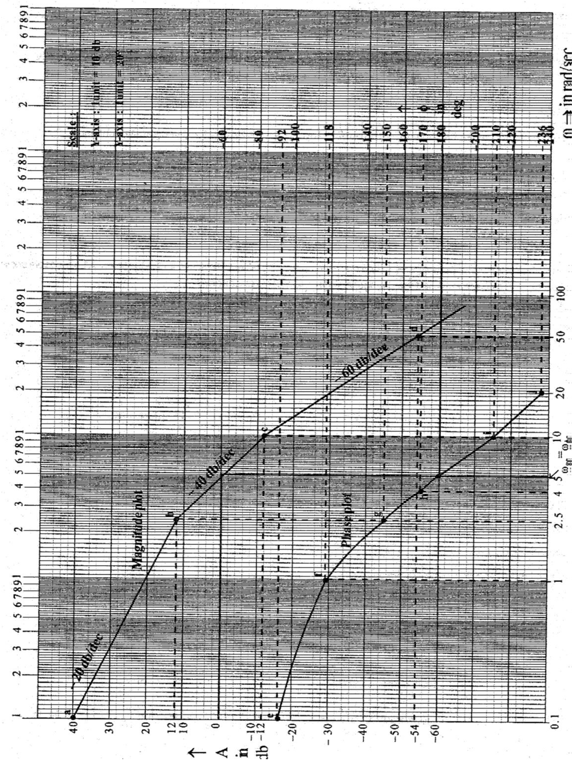

The phase angles of various values of ω are calculated and listed in table 2.

# TABLE:2

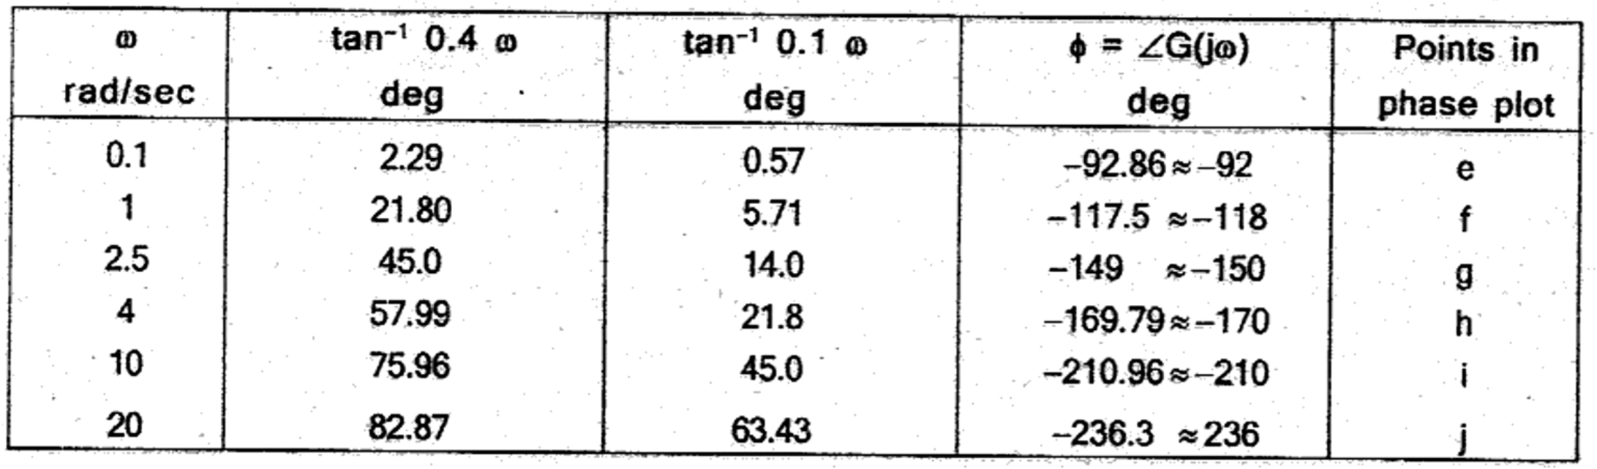

On the same semilog graph sheet choose a scale of 1 unit=20° on the y-axis on the right

side of semilog graph sheet. Mark the phase angles on the graph sheet and join the graph by smooth curve.

# RESULT:

1. Gain cross over frequency = 5r/s
2. Phase cross over frequency = 5r/s.

# 2. The open loop transfer function of a unity feedback system is G(S) = 1/ S (1+S) (1+2S) Sketch the Polarplot and determine the Gain margin and Phase margin

**Ans:**

# SOLUTION

Given that, G(s) = 1/s(1+s)(1+2s) Puts= jω

G(jω) = 1/ jω(1+jω)(1+2jω)

The corner frequencies are ωc1= 1/2= 0.5 r/s ωc2 = 1 r/s. The magnitude and phase angle

of G(jω) are calculated for the corner frequencies and for frequencies around comer frequencies and tabulated in table. The polar plot using polar coordinates is sketched on a polar graph sheet as shown in figure.

G(jω) = 1

(1+ j𝜔)(1 +2 j𝜔)

= 1

𝜔∠90°√(1+𝜔2) ∠ tan−1 𝜔√(1+4𝜔2)∠ tan−1 2𝜔

= 1

𝜔√(1+𝜔2) √(1+4𝜔2)

∠90° − tan−1 𝜔 − tan−1 2𝜔

|G(jω) | = 1

𝜔√(1+𝜔2)(1+4𝜔2)

= 1

𝜔√1+4𝜔2+𝜔2+4𝜔4

|G(jω) | = 1

𝜔√1+5𝜔2+4𝜔4

∠ G(jω) = -90°-tan−1 𝜔-tan−1 2𝜔

# Table:

**Magnitude and phase of** (j𝜔) **at various frequencies**

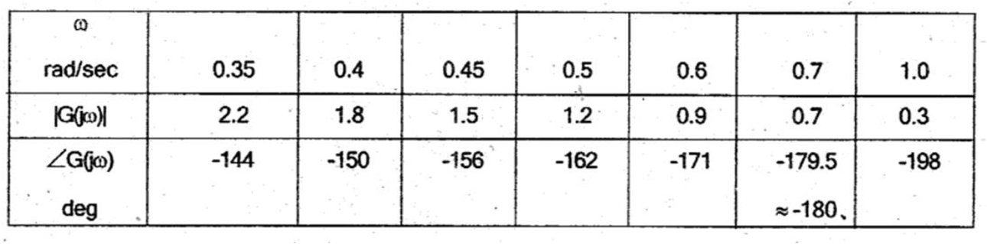

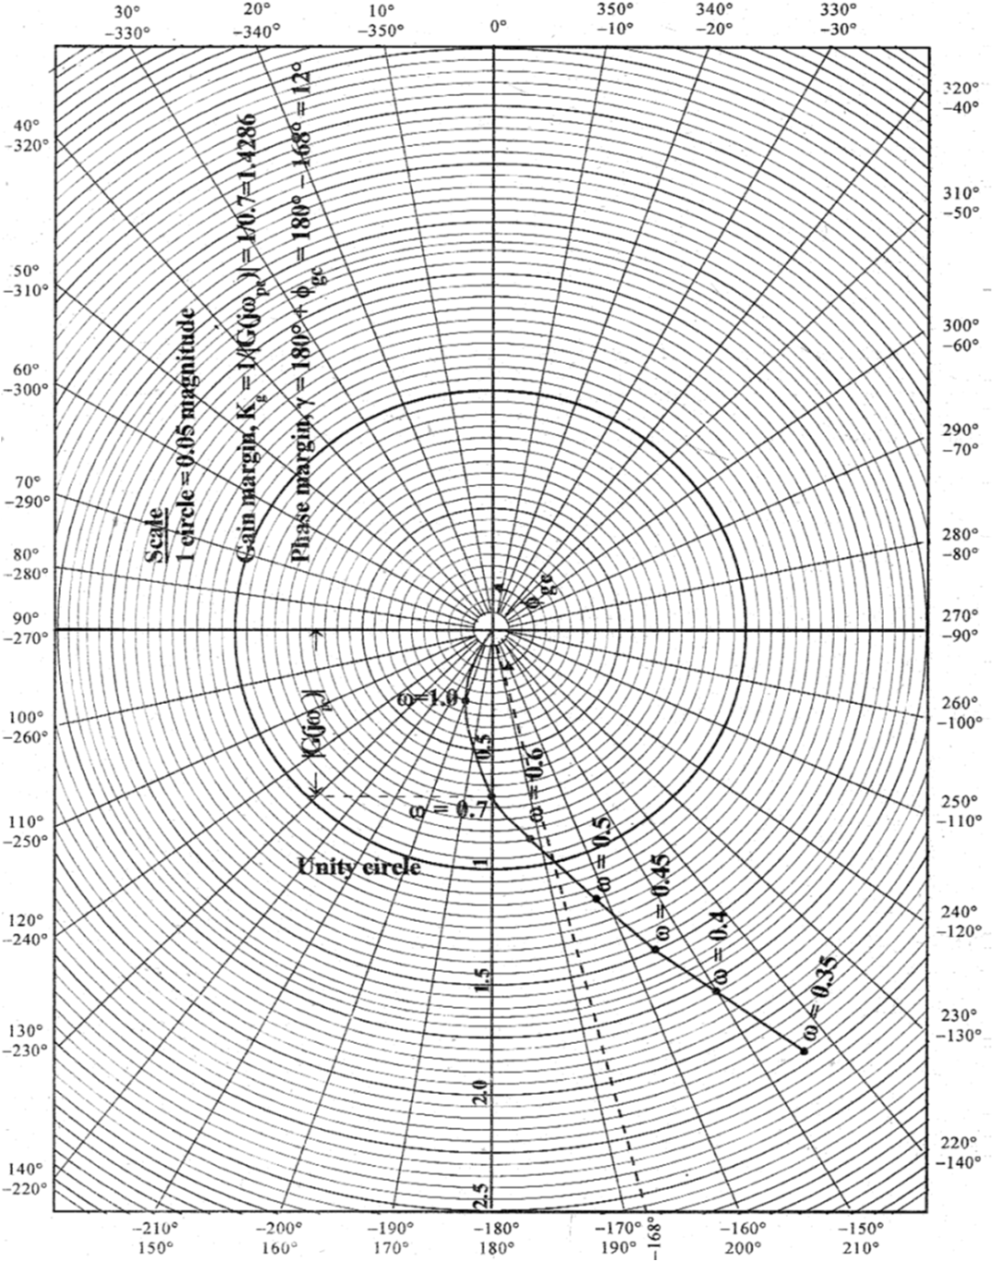

# RESULT:

1. Gain margin, Kg = 1.42
2. Phase margin, γ = +12°
3. **What is compensation? Why it is needed for control system? Explain the types of compensation Ans:**A drive system having closed loop control may not be satisfactory with regard to its stability

characteristics, speed of response and steady-state accuracy. The system may be oscillatory or even unstable. It may have either extremely fast or very sluggish response. The errors under steady-state between the actual and desired values may be excessive and not acceptable. Therefore, a necessity arises to modify the system or system parameters to provide the desired performance with respect to the above characteristics. This has certain practical limitations, such as size, range, and cost of available components. Sometimes there may not be any room to effect the change in the parameters.

In such cases the performance of the drive is improved by adding additional components to it. The method of improving the performance in this way is called **compensation**

**TYPES OF COMPENSATION**

**Series Compensation or Cascade Compensation**

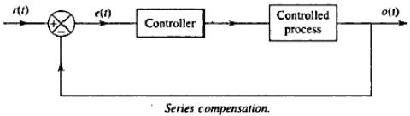This is the most commonly used system where the controller is placed in series with the controlled process. Figure shows the series compensation

**Feedback compensation or Parallel compensation**

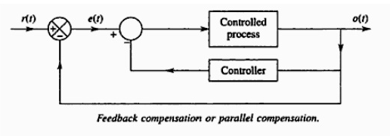This is the system where the controller is placed in the sensor feedback path as shown in fig.

**State Feedback Compensation**

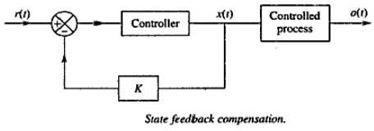This is a system which generates the control signal by feeding back the state variables through constant real gains. The scheme is termed state feedback. It is shown in Fig.

The compensation schemes shown in Figs above have one degree of freedom, since there is only one controller in each system. The demerit with one degree of freedom controllers is that the performance criteria that can be realized are limited.

That is why there are compensation schemes which have two degree freedoms, such as: (a)Series-feedback compensation

(b) Feed forward compensation

**Series-Feedback Compensation**

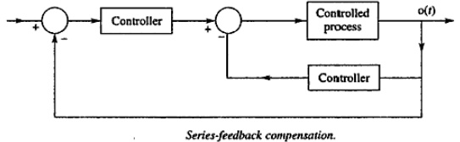Series-feedback compensation is the scheme for which a series controller and a feedback controller are used. Figure 9.6 shows the series-feedback compensation scheme.

**Feed forward Compensation**

The feed forward controller is placed in series with the closed-loop system which has a controller in the forward path Orig. 9.71. In Fig. 9.8, Feed forward the is placed in parallel with the controller in the forward path. The commonly used controllers in the above-mentioned compensation schemes are now described in the section below.

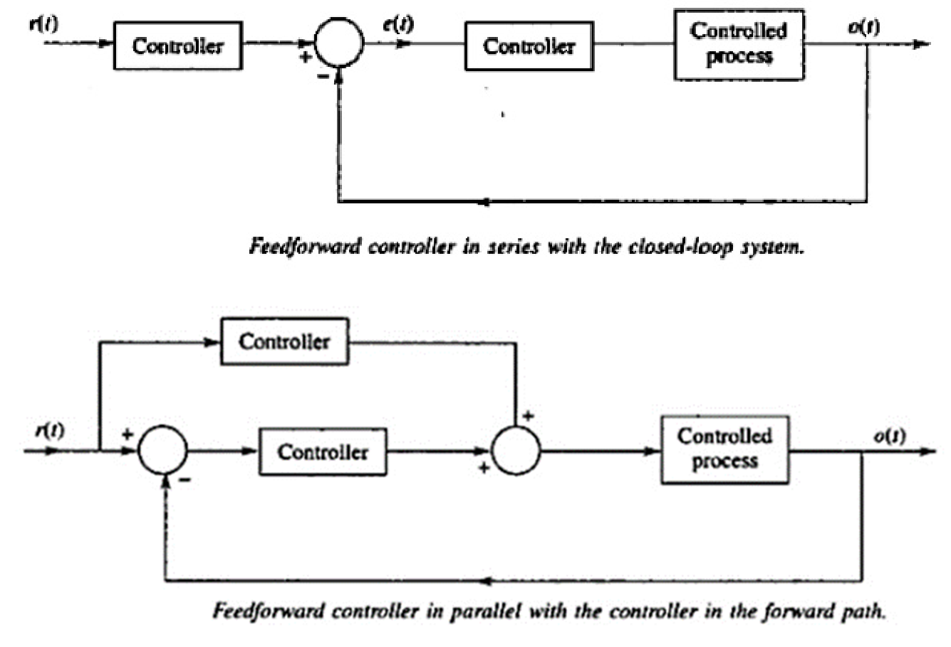

**Lead Compensator**

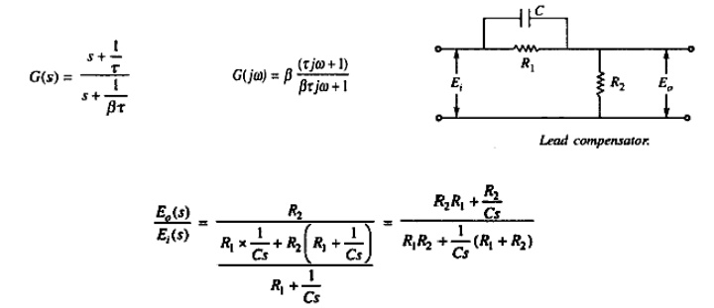It has a zero and a pole with zero closer to the origin. The general form of the transfer function of the load compensator is

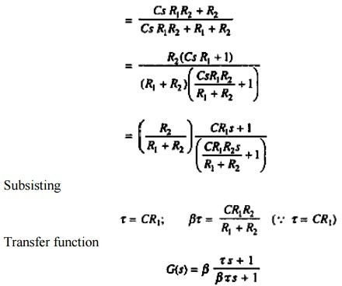

**Lag Compensator**

It has a zero and a pole with the zero situated on the left of the pole on the negative real axis. The general form of the transfer function of the lag compensator is

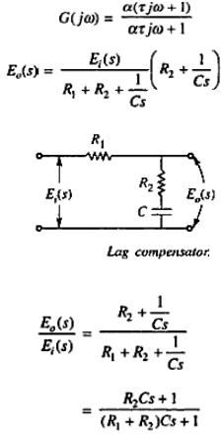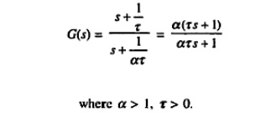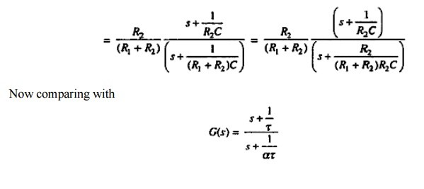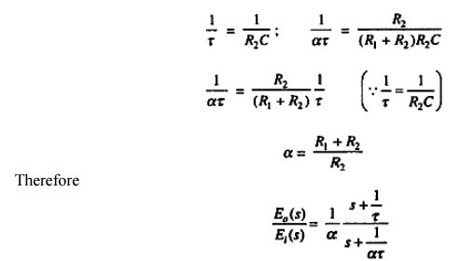

Therefore, the frequency response of the above transfer function will be

**Lag-Lead Compensator**

The lag-lead compensator is the combination of a lag compensator and a lead compensator. The lag-section is provided with one real pole and one real zero, the pole being to the right of zero, whereas the lead section has one real pole and one real came with the zero being to the right of the pole.

The transfer function of the lag-lead compensator will be

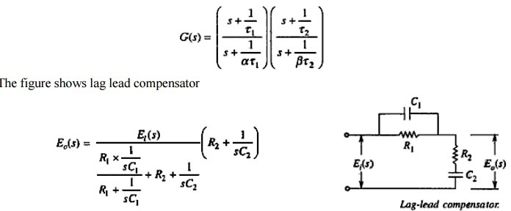

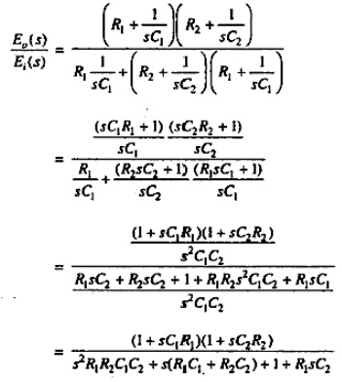

# Explain the procedure for lead compensation and lag compensation. Ans:

**Phase Lead Compensation**

A system which has one pole and one dominating zero (the zero which is closer to the origin than all over zeros is known as dominating zero.) is known as lead network. If we want to add a dominating zero for **compensation in control system** then we have to select **lead compensation** network.

The basic requirement of the phase lead network is that all poles and zeros of the transfer function of the network must lie on (-)ve real axis interlacing each other with a zero located at the origin of nearest origin. Given below is the circuit diagram for the phase **lead compensation** network.

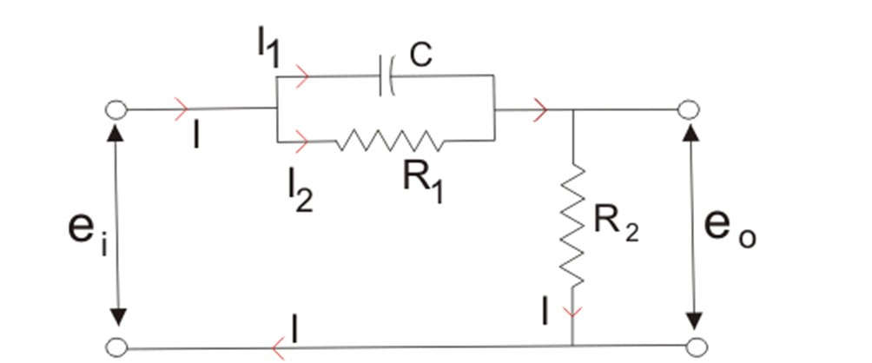

Phase Lead Compensation Network From above circuit we get,

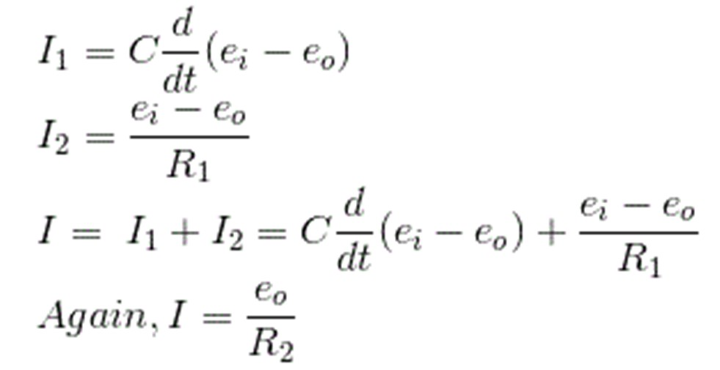

Equating above expression of I we get,

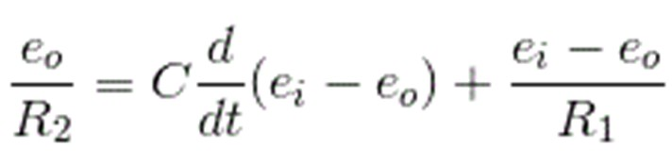

Now let us determine the transfer function for the given network and the transfer function can be determined by finding the ratio of the output voltage to the input voltage.

So taking Laplace transform of both side of above equations,

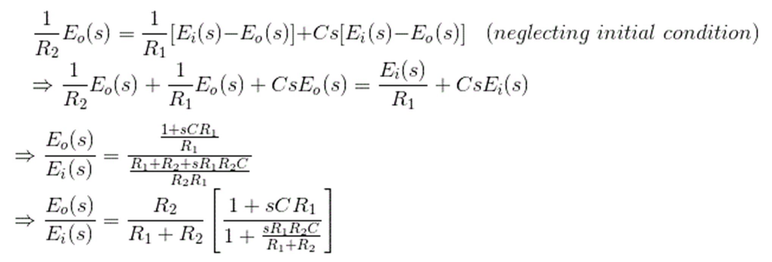

On substituting the α = (R1 +R2)/ R2 and T = {(R1R2) /(R1 +R2)} in the above equation.

Where, T and α are respectively the time constant and attenuation constant, we have

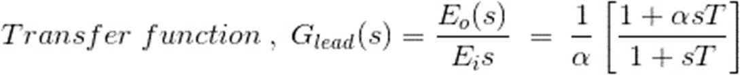

The above network can be visualized as an amplifier with a gain of 1/α. Let us draw the pole zero plot for the above transfer function.

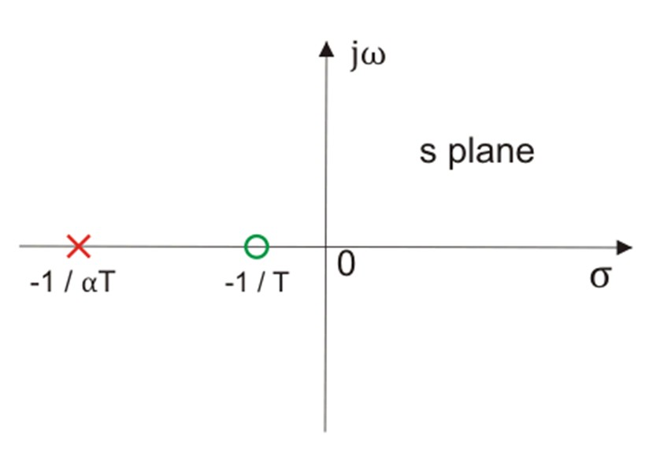

Pole Zero Plot of Lead Compensating Network

Clearly we have -1/T (which is a zero of the transfer function) is closer to origin than the -1/(αT) (which is the pole of the transfer function).Thus we can say in the lead compensator zero is more dominating than the pole and because of this lead network introduces positive phase angle to the system when connected in series.

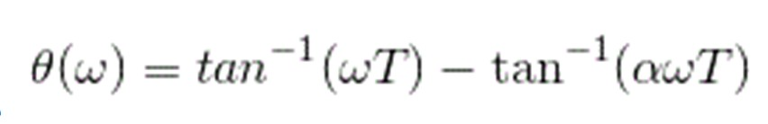Let us substitute s = jω in the above transfer function and also we have α < 1. On finding the phase angle

function for the transfer function we have

Now in order to find put the maximum phase lead occurs at a frequency let us differentiate this phase function and equate it to zero. On solving the above equation we get

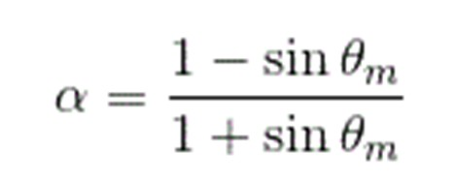

Where, θm is the maximum phase lead angle. And the corresponding magnitude of the transfer function at

maximum θm is 1/a.

# Phase Lag Compensation

A system which has one zero and one dominating pole ( the pole which is closer to origin that all other poles is known as dominating pole) is known as lag network. If we want to add a dominating pole for **compensation in control system** then, we have to select a **lag compensation** network.

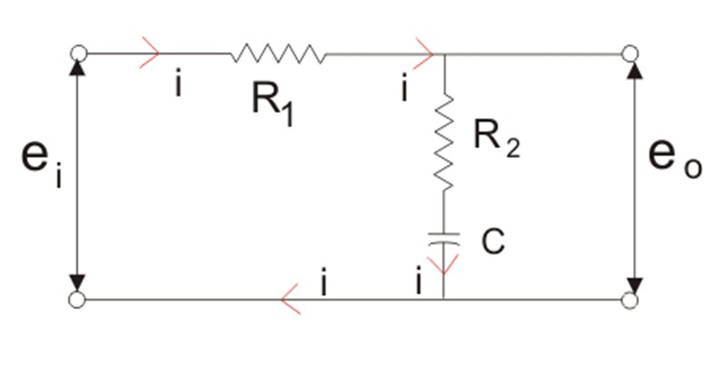The basic requirement of the phase lag network is that all poles and zeros of the transfer function of the network must lie in (-)ve real axis interlacing each other with a pole located or on the nearest to the origin. Given below is the circuit diagram for the phase **lag compensation** network.

Phase Lag Compensating Network

We will have the output at the series combination of the resistor R2 and the capacitor C. From the above circuit diagram, we get

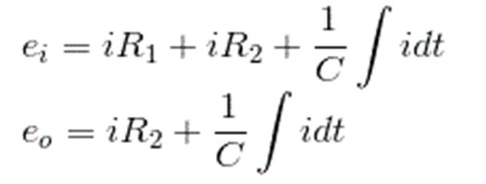

Now let us determine the transfer function for the given network and the transfer function can be determined by finding the ratio of the output voltage to the input voltage.

Taking Laplace transform of above two equation we get,

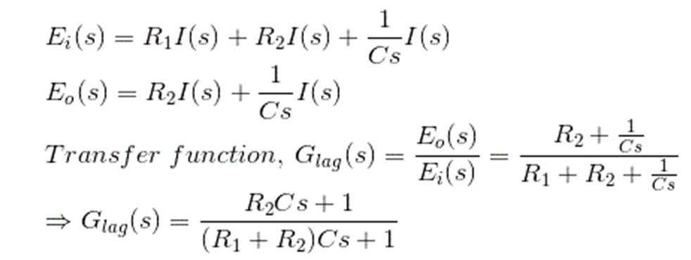

On substituting the in the above equation (Where, T and β are respectively the time constant and DC gain),

we have

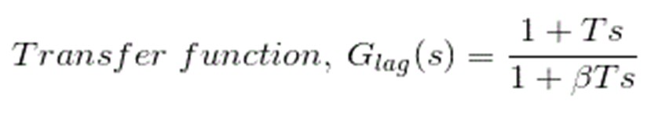

The above network provides a high frequency gain of 1 / β. Let us draw the pole zero plot for the above

transfer function.

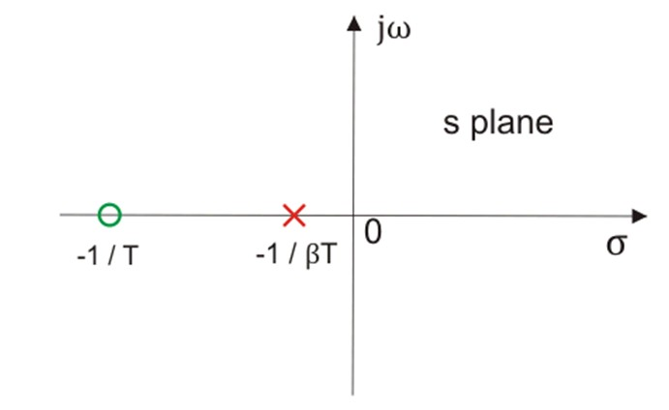

Pole Zero Plot of Lag Network

Clearly we have -1/T (which is a zero of the transfer function) is far to origin than the -1 / (βT)(which is the pole of the transfer function). Thus we can say in the lag compensator pole is more dominating than the zero and because of this lag network introduces negative phase angle to the system when connected in series.

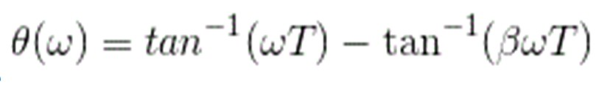Let us substitute s = jω in the above transfer function and also we have a < 1. On finding the phase angle

function for the transfer function we have

Now in order to find put the maximum phase lag occurs at a frequency let us differentiate this phase function and equate it to zero. On solving the above equation we get

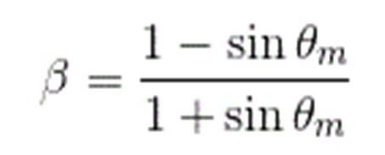

Where, θm is the maximum phase lead angle. Remember β is generally chosen to be greater than 10.

# Explain the design procedure for lag-lead compensation.

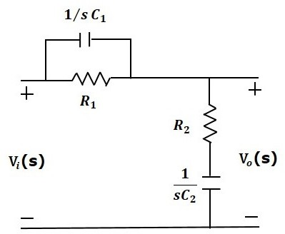**Ans:**Lag-Lead compensator is an electrical network which produces phase lag at one frequency region and phase lead at other frequency region. It is a combination of both the lag and the lead compensators. The lag- lead compensator circuit in the ‘s’ domain is shown in the following figure.

This circuit looks like both the compensators are cascaded. So, the transfer function of this circuit will be the product of transfer functions of the lead and the lag compensators.

Vo(s)Vi(s)=β(sτ1+1βsτ1+1)1α(s+1τ2s+1ατ2)Vo(s)Vi(s)=β(sτ1+1βsτ1+1)1α(s+1τ2s+1ατ2)

We know αβ=1αβ=1.

⇒Vo(s)Vi(s)=(s+1τ1s+1βτ1)(s+1τ2s+1ατ2)⇒Vo(s)Vi(s)=(s+1τ1s+1βτ1)(s+1τ2s+1ατ2)

Where,

τ1=R1C1τ1=R1C1 τ2=R2C2

# PART IV

**UNIVERSITY EXAM QUESTION PATTERN – 6 MARK (EACH QUESTION CARRIES 2 MARKS)**

# Define BIBO Stability. Ans:

A BIBO (bounded-input bounded-output) stable system is a system for which the outputs will remain bounded for all time, for any finite initial condition and input. A continuous-time linear time-invariant system is BIBO stable if and only if all the poles of the system have real parts less than 0

# What is impulse response? Ans:

In signal processing, the impulse response, or impulse response function (IRF), of a dynamic system is its output when presented with a brief input signal, called an impulse. More generally, an impulse response is the reaction of any dynamic system in response to some external change. In both cases, the impulse response describes the reaction of the system as a function of time (or possibly as a function of some other independent variable that parameterizes the dynamic behavior of the system).

# What is characteristic equation? Ans:

Characteristic Equation of a linear system is obtained by equating the denominator polynomial of the transfer function to zero

# What is routh stability condition? Ans:

Routh Hurwitz criterion states that any system can be stable if and only if all the roots of the first column have the same sign and if it does not has the same sign or there is a sign change then the number of sign changes in the first column is equal to the number of roots of the characteristic equation in the right half of the s-plane i.e. equals to the number of roots with positive real parts.

# What is auxiliary polynomial? Ans:

The row of polynomial which is just above the row containing the zeroes is called the "auxiliary polynomial".

# What is quadrantal symmetry? Ans:

The symmetry of roots with respect to both real and imaginary axis called quadrantal symmetry

# What is Nyquist stability criterion? Ans:

Nyquist stability criterion (or Nyquist criteria) is a graphical technique used in control engineering for determining the stability of a dynamical system. As Nyquist stability criteria only considers the Nyquist plot of open-loop control systems, it can be applied without explicitly computing the poles and zeros of either the closed-loop or open-loop system.

As a result, Nyquist criteria can be applied to systems defined by non-rational functions (such as systems with delays). Unlike Bode plots, it can handle transfer functions with singularities in the right half-plane.

# What is root locus? Ans:

The root locus is a graphical representation in s-domain and it is symmetrical about the real axis. Because the open loop poles and zeros exist in the s-domain having the values either as real or as complex conjugate pairs. In this chapter, let us discuss how to construct (draw) the root locus.

# What are asymptotes? Ans:

Asymptote originates from the center of gravity or centroid and goes to infinity at definite some angle. Asymptotes provide direction to the root locus when they depart break away points.

# What is centroid, how it is calculated? Ans:

The center point of the object is what we refer to as the centroid. The point at which a triangle's three medians intersect is called the centroid of the triangle. We can also define the centroid as the point of intersection of the three medians. The median refers to the line joining the midpoint of a side to the opposite vertex of a triangle. The triangle's centroid divides the median in the ratio of 2:1. We can calculate the centroid by taking the average of the x-coordinates and the y-coordinates of the vertices of the triangle.

# PART V

**UNIVERSITY EXAM QUESTION PATTERN – 6 MARK (EACH QUESTION CARRIES 2 MARKS) ANSWER ANY 10 QUESTION**

# What is sampled data control system? Ans:

A type of digital control system in which one or more of the input or output signals is a continuous, or analog, signal that has been sampled. There are two aspects of a sampled signal: sampling in time and quantization in amplitude. Sampling refers to the process of converting an analog signal from a continuously valued range of amplitude values to one of a finite set of possible numerical values. This sampling typically occurs at a regular sampling rate, but for some applications the sampling may be aperiodic or random.

# State (Shanon’s) sampling theorem. Ans:

According to the sampling theorem (Shannon, 1949), to reconstruct a one-dimensional signal from a set of samples, the sampling rate must be equal to or greater than twice the highest frequency in the signal.

Applying this theorem to the cone mosaic, with a given spacing between receptors, the highest spatial

frequency that is adequately sampled, known as the Nyquist limit, is half the sampling frequency of the mosaic.

# What is periodic sampling? Ans:

Periodic sampling, the process of representing a continuous signal with a se- quence of discrete data values, pervades the field of digital signal processing. In practice, sampling is performed by applying a continuous signal to an ana- log-to-digital (A/D) converter whose output is a series of digital values.

# What are hold circuits? Ans:

A Sample and Hold Circuit, sometimes represented as S/H Circuit or S & H Circuit, is usually used with an Analog to Digital Converter to sample the input analog signal and hold the sampled signal.

# What are state variables? Ans:

A state variable is one of the set of variables that are used to describe the mathematical "state" of a dynamical system. Intuitively, the state of a system describes enough about the system to determine its future behaviour in the absence of any external forces affecting the system.

# What is the state space? Ans:

a state-space representation is a mathematical model of a physical system as a set of input, output and state variables related by first-order differential equations or difference equations. State variables are variables whose values evolve over time in a way that depends on the values they have at any given time and on the externally imposed values of input variables. Output variables’ values depend on the values of the state variables.

# What are phase variables? Ans:

The phase variables are defined as those particular state variables which are obtained from one of the system variables & its (n-1) derivatives. Often the variables used is the system output & the remaining state variables are then derivatives of the output

# What is a state vector? Ans:

If n state variables are needed to completely describe the behaviour of a given system, then these n state variables can be considered the n components of a vector X. Such a vector is called a state vector.

# Define Acquisition time.

**Ans:**Acquisition Time is the time that it takes for the ADC to acquire and convert an analog signal to a digital value. The conversion time is a sum of:

(Sample Time) + (Calibration Time) + (Charge Distribution Time) + (Synchronization Time)

# PART VA

**UNIVERSITY EXAM QUESTION PATTERN – 6 MARK (EACH QUESTION CARRIES 6 MARKS) ANSWER ALL QUESTION**

# a. Explain the importance of controllability and observability of the control system model in the design of the control system.

**Ans:**Controllability and observability are two important properties of state models which are to be studied prior to designing a controller. Controllability deals with the possibility of forcing the system to a particular state by application of a control input. If a state is uncontrollable then no input will be able to control that state. On the other hand whether or not the initial states can be observed from the output is determined using observability property. Thus if a state is not observable then the controller will not be able to determine its behavior from the system output and hence not be able to use that state to stabilize the system.

# Explain sampling theorem and Sample & Hold operation briefly.

**Ans:** A continuous time signal can be represented in its samples and can be recovered back when sampling frequency fs is greater than or equal to the twice the highest frequency component of message signal. i. e.

fs≥2fm.

**Proof:** Consider a continuous time signal x(t). The spectrum of x(t) is a band limited to fm Hz i.e. the spectrum

of x(t) is zero for |ω|>ωm.

Sampling of input signal x(t) can be obtained by multiplying x(t) with an impulse train δ(t) of period Ts. The output of multiplier is a discrete signal called sampled signal which is represented with y(t) in the following diagrams:

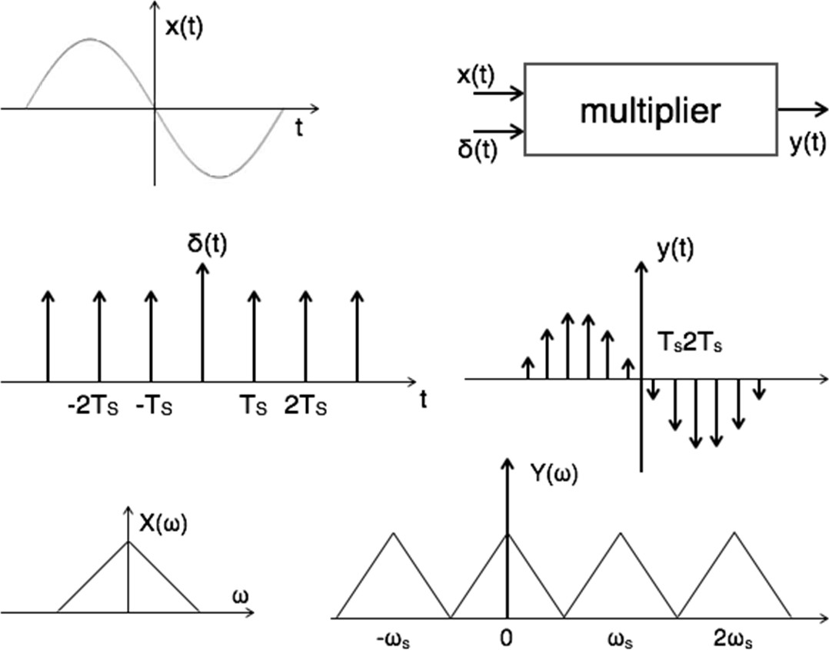

Here, you can observe that the sampled signal takes the period of impulse. The process of sampling can be explained by the following mathematical expression:

Sampled signaly(t)=x(t).δ(t)......(1)Sampled signaly(t)=x(t).δ(t) (1)

The trigonometric Fourier series representation of δδ(t) is given by

δ(t)=a0+Σ∞n=1(ancosnωst+bnsinnωst)......(2)δ(t)=a0+Σn=1∞(ancos nωst+bnsin nωst) (2)

Where a0=1Ts∫T2−T2δ(t)dt=1Tsδ(0)=1Tsa0=1Ts∫−T2T2δ(t)dt=1Tsδ(0)=1Ts an=2Ts∫T2−T2δ(t)cosnωsdt=2T2δ(0)cosnωs0=2Tan=2Ts∫−T2T2δ(t)cos nωsdt=2T2δ(0)cos nωs0=2T bn=2Ts∫T2−T2δ(t)sinnωstdt=2Tsδ(0)sinnωs0=0bn=2Ts∫−T2T2δ(t)sin nωstdt=2Tsδ(0)sin nωs0=0

Substitute above values in equation 2.

∴δ(t)=1Ts+Σ∞n=1(2Tscosnωst+0)∴δ(t)=1Ts+Σn=1∞(2Tscos nωst+0) Substitute δ(t) in equation 1.

→y(t)=x(t).δ(t)→y(t)=x(t).δ(t)

=x(t)[1Ts+Σ∞n=1(2Tscosnωst)]=x(t)[1Ts+Σn=1∞(2Tscos nωst)]

=1Ts[x(t)+2Σ∞n=1(cosnωst)x(t)]=1Ts[x(t)+2Σn=1∞(cos nωst)x(t)] y(t)=1Ts[x(t)+2cosωst.x(t)+2cos2ωst.x(t)+2cos3ωst.x(t)......]y(t)=1Ts[x(t)+2cos ωst.x(t)+2cos 2ωst.x(t)+2c os 3ωst.x(t) ]

Take Fourier transform on both sides.

Y(ω)=1Ts[X(ω)+X(ω−ωs)+X(ω+ωs)+X(ω−2ωs)+X(ω+2ωs)+ ]Y(ω)=1Ts[X(ω)+X(ω−ωs)+X(ω+ωs)+X(ω−2ωs)+X(ω+

2ωs)+ ]

∴Y(ω)=1TsΣ∞n=−∞X(ω−nωs)wheren=0,±1,±2,...∴Y(ω)=1TsΣn=−∞∞X(ω−nωs)wheren=0,±1,±2,...

To reconstruct x(t), you must recover input signal spectrum X(ω) from sampled signal spectrum Y(ω), which is possible when there is no overlapping between the cycles of Y(ω).